ANSH PANDEY 2300290130036 IT – (A) - 36

**LAB – 5**

* 1. **WAP to Create a class MyThread derived from Thread class and override the run method. Create a class ThreadDemo having a main method. Create 2 objects of MyThread class and observe the behavior of threads.**

*// MyThread.java*

class **MyThread** *extends Thread* {

*private* String threadName**;**

MyThread(String **name**) { threadName **=** name**;**

}

@**Override**

*public void* run() {

**for** (*int* i **=** 1**;** i **<=** 5**;** i**++**) { System**.***out***.**println(threadName **+** " - Count: " **+** i)**; try** {

Thread**.**sleep(500)**;** *// Pause for half a second*

} **catch** (InterruptedException **e**) { System**.***out***.**println(threadName **+** " interrupted.")**;**

}

}

System**.***out***.**println(threadName **+** " finished.")**;**

}

}

*public* class **ThreadDemo** {

*public static void* main(String[] **args**) {

MyThread thread1 **= new** MyThread("Thread-1")**;** MyThread thread2 **= new** MyThread("Thread-2")**;** thread1**.**start()**;**

thread2**.**start()**;**

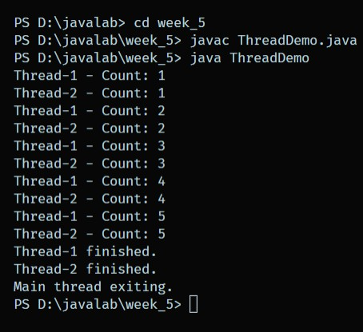

**try** {

thread1**.**join()**;** thread2**.**join()**;**

} **catch** (InterruptedException **e**) { System**.***out***.**println("Main thread interrupted.")**;**

}

System**.***out***.**println("Main thread exiting.")**;**

}

}

* 1. **WAP to Modify the above to create MyThread class by implementing Runnable interface and observe the behavior of threads.**

*// MyThread.java*

class **MyThread** *extends Thread* {

*private* String threadName**;**

MyThread(String **name**) { threadName **=** name**;**

}

@**Override**

*public void* run() {

*// Run method logic*

**for** (*int* i **=** 1**;** i **<=** 5**;** i**++**) { System**.***out***.**println(threadName **+** " - Count: " **+** i)**; try** {

Thread**.**sleep(500)**;** *// Pause for half a second*

} **catch** (InterruptedException **e**) { System**.***out***.**println(threadName **+** " interrupted.")**;**

}

}

System**.***out***.**println(threadName **+** " finished.")**;**

}

}

*public* class **MyThreadProgram** {

*public static void* main(String[] **args**) {

MyThread runnable1 **= new** MyThread("Thread-1")**;** MyThread runnable2 **= new** MyThread("Thread-2")**;**

Thread thread1 **= new** Thread(runnable1)**;** Thread thread2 **= new** Thread(runnable2)**;** thread1**.**start()**;**

thread2**.**start()**; try** {

thread1**.**join()**;** thread2**.**join()**;**

} **catch** (InterruptedException **e**) { System**.***out***.**println("Main thread interrupted.")**;**

}

System**.***out***.**println("Main thread exiting.")**;**

}

}

